- Open control panel as Admin
- Open Network and Internet
- Open Network and Sharing Center
- Open change Adapter settings
- Right click ethernet adapter, select properties
- Find Internet Protocol and select properties
- Change settings to look like this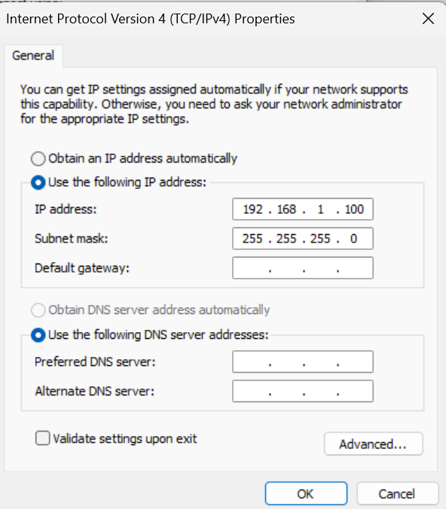
- Note your fire wall may need to be disabled

